**Creating instances and installing nginx and apply to ALB**

* Creating three instances and installing Nginx in 3 servers

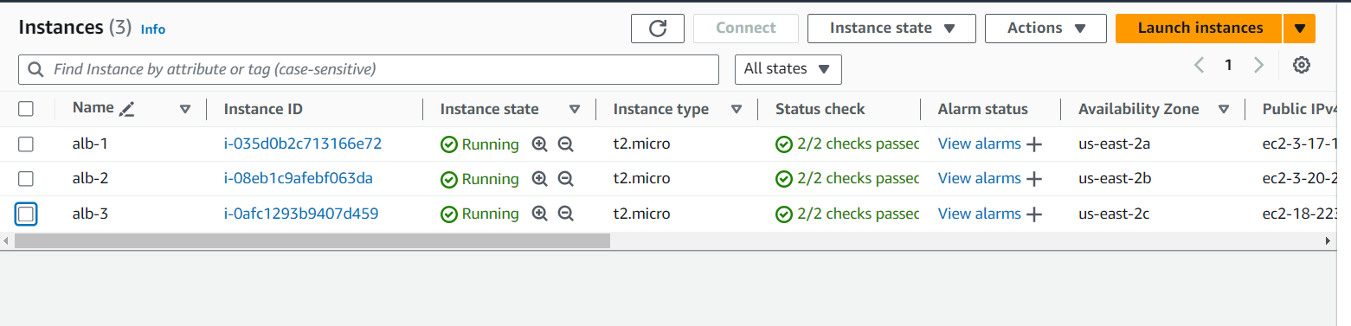

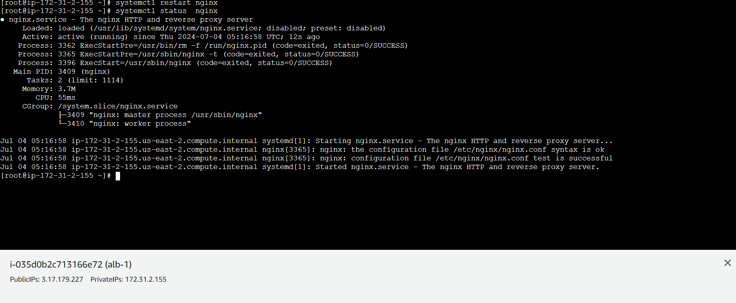

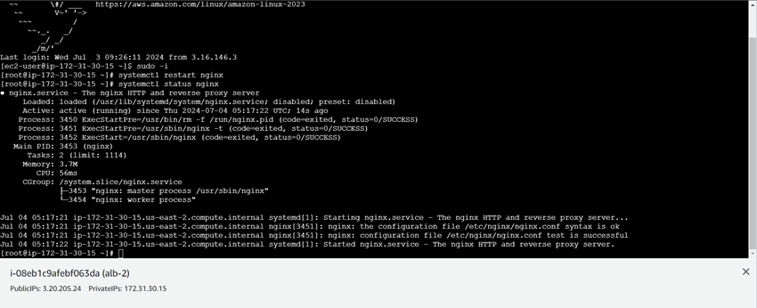

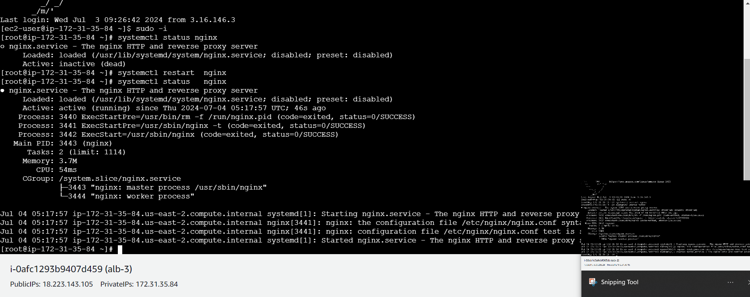

* Creating target group

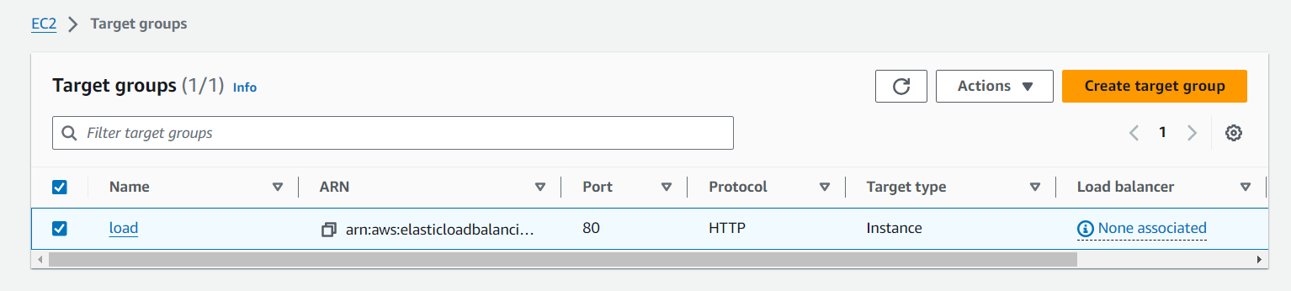

* Creating load balancer

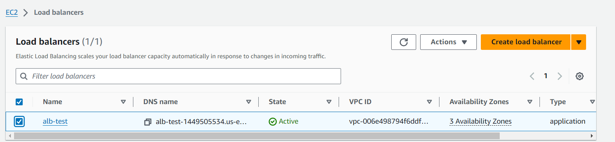

* Testing LoadBalancer with DNS: alb-test-1449505534.us-east-2.elb.amazonaws.com

This is web server 1

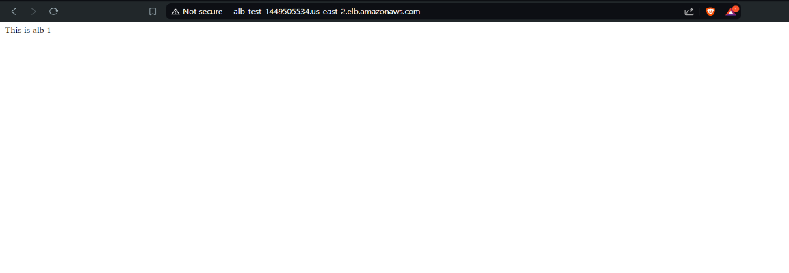

This is web server 2

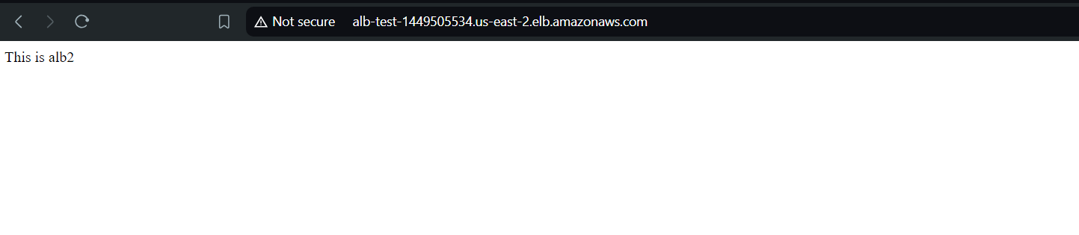

This is web server 3

